MARCIA LECLERC  MAYOR | 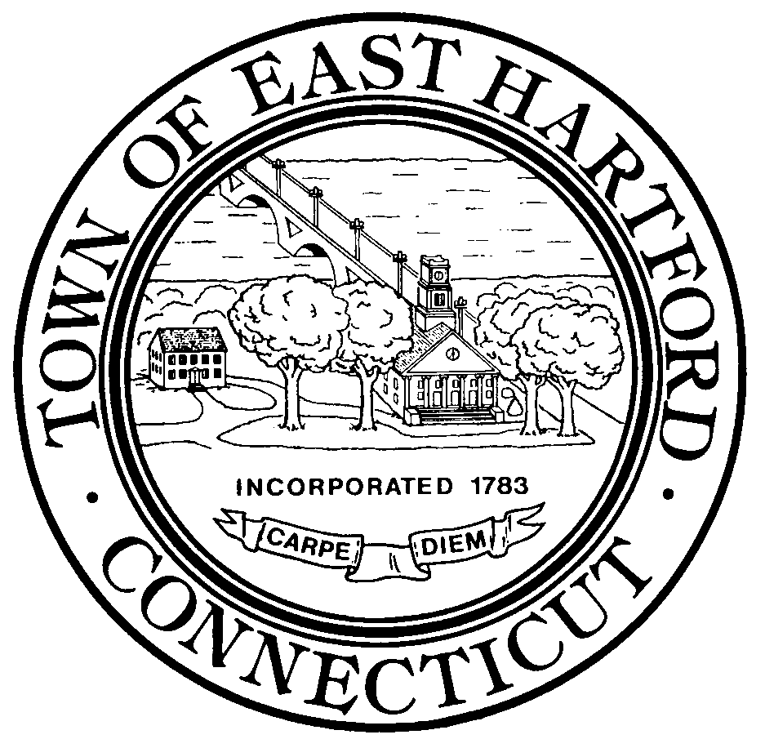TOWN OF EAST HARTFORD | (860) 291-7300
 | 740 Main Street | FAX (860) 291-7298
DEVELOPMENT DEPARTMENT | East Hartford, Connecticut 06108 | www.easthartfordct.com

East Hartford Silver Lane Advisory Committee
Meeting Summary
Wednesday, September 27, 2017
4:00 pm
Welling Conference Room – 2nd floor Town Hall

PRESENT - Mayor Leclerc ; Frank Collins, Economic Development Commission; Tom York, Goman & York; Robin Pearson, Redevelopment Agency; Todd Andrews, Goodwin College; Chad Freitas, Resident Representative; Dan Matos and James Matos, The Matos Group; Rebecca Augur, Milone & MacBroom, Inc. (MMI); Tim Bockus, DPW Director; Emily Hultquist, Jillian Massey, and Mary Ellen Kowalewski, CRCOG; Casey Hardin and Kim Rudy, Transystems,; Paul Mainuli, Board of Education; Eileen Buckheit, Development Director; Jeff Cormier, Town Planner; Rich Gentile, Assistant Corporation Counsel; Patrick Zapatka, DOT
ABSENT – Peter Bonzani, MaryEllen Dombrowski, Craig Stevenson
CALL TO ORDER
Meeting was called to order at 4:00 p.m.
UPDATE
Rebecca Augur provided a developers panel recap for the committee. There was a confirmation by the panel that market-rate residential is a good opportunity for the corridor. They should be amenity rich and create a sense of place. It is different that the market from Downtown Hartford, more of a suburban, low-rise model. Developers would look for 25-35 units per acre. Good opportunity for food and beverage industry, sports and recreation, and medical. Property assemblage more difficult, but would create a standout opportunity in the region. CTfastrak should be aggressively pursued.

Presentation
Emily Hultquist provided some background on the transportation study, including the scope of work and timeline. The study is integrated with the land-use planning being conducted by MMI. Casey Hardin explained first step is an existing conditions analysis. He provided details on how the current corridor operates with daily traffic, crash data, bus routes and stops, bicycles and pedestrians, and a detailed look at each segment of the corridor.
Next steps in the process:
- Next AC meeting will be in October
- First public meeting will be in near future
- Newsletter

ADJOURNMENT
Meeting concluded 5:30 pm.

