For Immediate Release: Wednesday, July 18, 2018

East Hartford Police Department’s K-9 Capo Has Received Donation of Body Armor

East Hartford Police Department’s K9 Capo has received a bullet and stab protective vest thanks to a charitable donation from non-profit organization Vested Interest in K9s, Inc. The vest was sponsored by Protectors of Animals of East Hartford, CT and embroidered with the sentiment “This gift of protection provided by Protectors of Animals”.

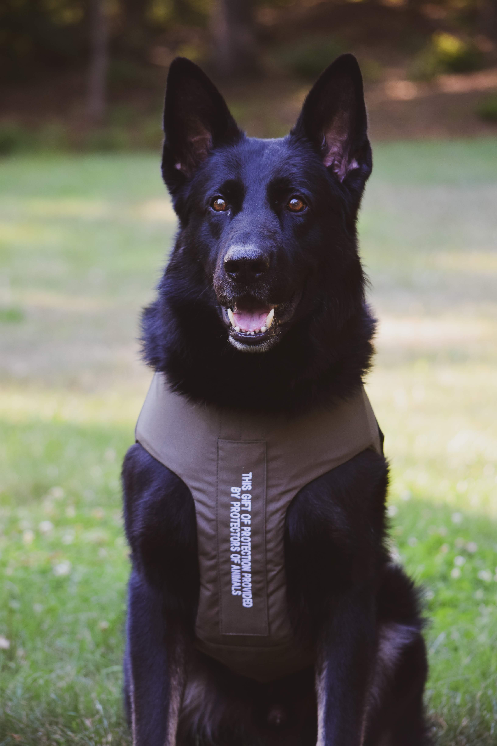
“Very special thanks go to the generosity and efforts of Vested Interest In K9s, Incorporated, and Protectors of Animals of East Hartford,” said East Hartford police Chief Scott Sansom. “Safety is our top priority, not only for the public, but for our officers as well, which includes our K-9s.”

“I would also like to extend my gratitude to Vested Interest In K9s, Inc., and to Protectors of Animals of East Hartford,” said East Hartford Mayor Marcia Leclerc. It is exciting to see the community come together around the safety of our entire Police Force.”

K9 Capo is a 3-year-old German Shepherd from Slovakia certified and primarily used for tracking and criminal apprehension. Capo is one of three K-9’s on patrol in East Hartford, and he recently began his third year on assignment to “day-shift” with his handler, veteran East Hartford Officer Juan Rivera. Capo has already helped in tracking and apprehending several criminals, as well as assisted with locating missing persons within East Hartford and surrounding communities.

Vested Interest in K9s, Inc. is a 501c(3) charity located in East Taunton, MA whose mission is to provide bullet and stab protective vests and other assistance to dogs of law enforcement and related agencies throughout the United States. The non-profit was established in 2009 to assist law enforcement agencies with this potentially lifesaving body armor for their four-legged K9 officers. Since its inception, Vested Interest in K9s, Inc. provided over 3,000 protective vests in 50 states, through private and corporate donations, at a value of 5.7 million dollars.

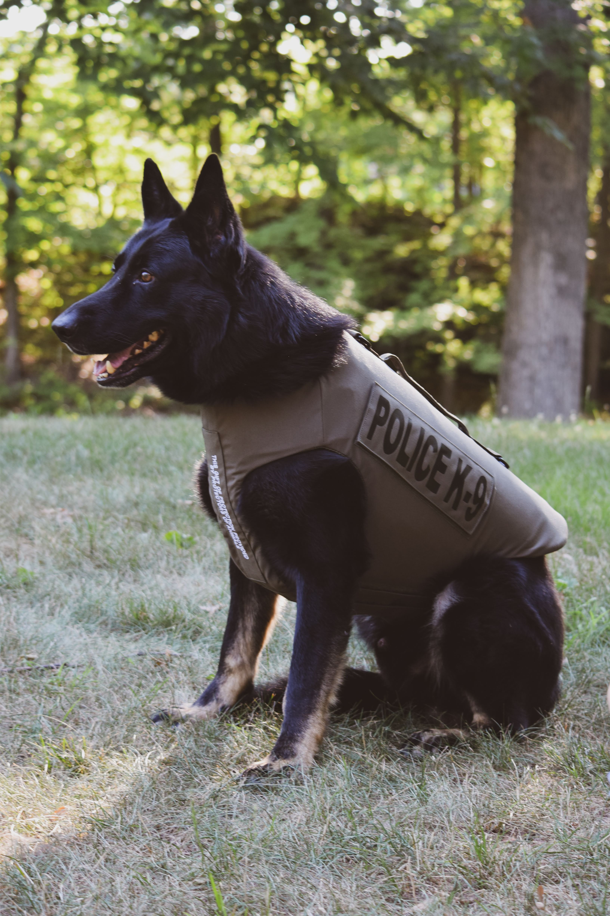
The program is open to dogs actively employed in the U.S. with law enforcement or related agencies who are certified and at least 20 months of age. New K9 graduates, as well as K9s with expired vests, are eligible to participate.

The donation to provide one protective vest for a law enforcement K9 is $950.00. Each vest has a value between $1,744 – $2,283, and a five-year warranty and an average weight of 4-5 lbs. There is an estimated 30,000 law enforcement K9s throughout the United States. For more information or to learn about volunteer opportunities, please call 508-824-6978. Vested Interest in K9s, Inc. provides information, lists events, and accepts tax-deductible donations of any denomination at www.vik9s.org or mailed to P.O. Box 9 East Taunton, MA 02718.

Lieutenant Joshua Litwin
Public Information Officer
East Hartford Police Department
31 School Street
East Hartford, CT 06108
Tel. 860-291-7569
Email: jlitwin@easthartfordct.gov
###

