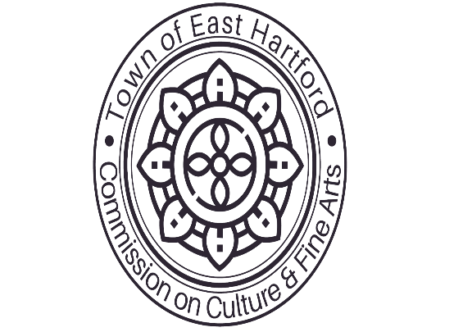
Town of East Hartford
Commission on Culture and Fine Arts
Meeting Agenda
Address: Raymond Library Meeting Room 1
840 Main St, East Hartford
Thursday, February 9th, 2023
7:00 pm

I. Roll Call

II. Approval of Minutes from January’s Meeting

III. Chair’s Report

IV. Correspondence
Guest/Public Remarks

V. Committee Report:
- Sarah Morgan, Library Director
- Children Library Programs
- EHSYF – Com. Amanda
- Intl Film Series – Com. Glynis
- Music –
- Arts – July event
- Poetry/Dance – Com. Tamara
- Immigration Events
- Native American Culture

VI. Old Business:
Theater tickets
Japanese Week
Mini-Grants
VII. New Business:
New ideas/ Projects
Juneteenth
Sound of Summer – East Hartford Night

VIII. Approval of Bills
Clerk

IX. Member’s Concerns

X. Adjournment

